**Sensors:**

**HC-SR04 ultrasonic distance sensor**

**Features:**

- sensor provides 2cm to 400cm of non-contact measurement functionality.

- accuracy up to 3mm.

- Affordable and widely used in DIY projects. Keep in mind that it may not be as robust or accurate as industrial-grade sensors.

**Working:**

**-** One acts as a transmitter that converts the electrical signal into 40 KHz ultrasonic sound pulses. The other acts as a receiver and listens for the transmitted pulses.

**Price:**

- 299 Rs

**Technical Specifications**

Operating Voltage DC 5V

Operating Current 15mA

Operating Frequency 40KHz

Max Range 4m

Min Range 2cm

Ranging Accuracy 3mm

Measuring Angle 15 degree

Trigger Input Signal 10µS TTL pulse

Dimension 45 x 20 x 15mm

**Image:**

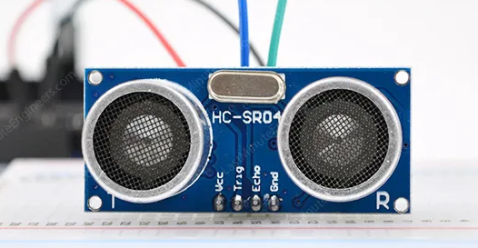

**Reference:**

<https://lastminuteengineers.com/arduino-sr04-ultrasonic-sensor-tutorial/>

**MaxBotix MB7389 HRXL-MaxSonar-WRMT:**

**Features:**

- It is a weather-resistant ultrasonic distance sensor with a range of 30 to 500 cm and a resolution of 1 mm.

- This sensor is ideal for outdoor applications such as a water tank or bin level measurement.

- It has a very small beam angle.

**Working:**

- One acts as a transmitter that converts the electrical signal into 40 KHz ultrasonic sound pulses. The other acts as a receiver and listens for the transmitted pulses.

**Price:**

- Rs.32,100.00 PKR

**Technical Specifications**

Operating voltage 2.7 – 5.5 V

Operating current 3.1 mA average at 5 V (98 mA peak)

Range 30* – 500 cm

Beam angle/shape See here

Protection IP67

Resolution 1 mm

Frequency 42 kHz

Reading rate 6.66 Hz

Sensor outputs Analog voltage, pulse width, RS232

Overall dimensions 22.1 x 19.9 x 25.11 mm

Operating temperature -40 – +65 °C

**Image:**

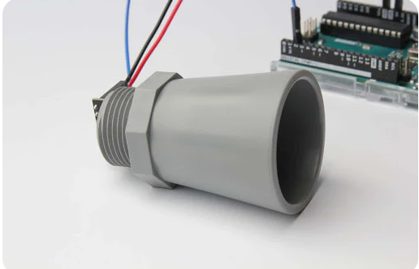

**Reference:**

https://maxbotix.com/blogs/blog/mb7389-x-arduino-tutorial-with-code-examples